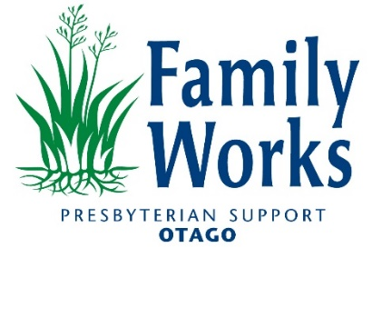

Strengthening Families Coordinator, Dunedin

Are you passionate about supporting whānau to achieve their hopes, dreams, and aspirations?

Can you facilitate the creation of a safe communication space for whanau?

Do you believe in placing tamariki, rangatahi, and whānau at the centre of your mahi, and walk this talk through really listening and hearing their story?

Then we have the role for you!

We are looking for a professional community minded person with a strong commitment to strengthening whānau voice to fill the role of Strengthening Families Coordinator.

This is a fixed-term position 30-40 hours (negotiable) per weekday between the hours of 8am-5pm. The role is based at our Dunedin Family Works office in Moray Place, however you will be working across the wider social sector community, including with community-based and government agencies as a Strengthening Families Co-ordinator.  This is currently a fixed term position until 24 December 2025.

**Are You**

* Someone with sound knowledge of Te Tiriti o Waitangi, and an understanding of working within a bi-cultural and multi-cultural framework.
* Able to facilitate professional meetings and hold the voice of the whānau, tamariki and rangatahi at the core.
* Great with interpersonal and advocacy skills and can prioritize working collaboratively.
* Understanding of the impact of social complexities and be able to use your skills and knowledge to support collaborative practice.
* Able to work autonomously whilst also being part of an Otago wide multi-disciplinary team.
* Exceptional in relationship management and have group facilitation experience, including a passion for training and development of Facilitators and Lead Agents.
* Someone with enthusiasm, energy, commitment and a good sense of humour.

**Some of What We Offer**

* Being part of a well-known and highly respected charitable organisation.
* Joining an internal and wider Dunedin community team that makes a real difference in people’s lives.
* Personal growth and career development opportunities.
* Significant on-the-job training.
* Discounts with local businesses.

**About Us**

Family Works is a service within Presbyterian Support Otago (PSO) that works to ensure every person is valued and grows in a safe and strong community. PSO is a Charitable Trust established in 1906 and is a leading provider of aged care, retirement living, and social services to the people of Otago and the wider South Island. With over 800 staff and 500 volunteers, we operate a highly regarded network of 8 care homes across Otago and we provide many other community-based social support programmes.

**Join the Family Works Team -** To apply click "Apply Now".

For further information contact Deb Gelling at Family Works on 0277147447

Please note applications will be reviewed as they are received, and this job vacancy could close prior to the closing date.

If you have difficulty applying, please email [recruitment@psotago.org.nz](mailto:recruitment@psotago.org.nz)

***Please note: Please apply only if you have the legal right to work in New Zealand.***